Aim: To apply navigation, routing, and gestures in a Flutter application

Theory:

Q1. What is Navigation in Flutter? Explain how Flutter moves from one screen to another using the Navigator class.
Navigation is moving between screens in Flutter. The Navigator class manages a stack of Route objects, using push() to add new screens and pop() to return to previous ones.

Q2. Explain the navigation stack mechanism in Flutter. (Use real-life example of stack of plates)
Navigation works like a plate stack—adding (pushing) a new plate on top shows a new screen. Removing (popping) the top plate returns to the previous screen below it.

Q3. What is Routing in Flutter?
Routing defines named paths to screens in Flutter. It allows navigation using route names instead of directly creating widgets, making navigation more organized and manageable.

Q4. What is a Gesture in Flutter? Explain the use of ‘GestureDetector’ widget.
A gesture is a physical interaction like tapping or swiping. GestureDetector is a widget that detects these interactions and executes corresponding callback functions.

Q5. What are different types of gestures supported in Flutter?
Flutter supports tap, double tap, long press, drag, pan, swipe, pinch, zoom, and rotate gestures through various gesture detector callback.
Code:
import 'package:flutter/material.dart';
void main() {
runApp(const MyApp());
}
class MyApp extends StatelessWidget {
const MyApp({super.key});
@override
Widget build(BuildContext context) {
return MaterialApp(
debugShowCheckedModeBanner: false,
initialRoute: '/',
routes: {
'/': (context) => const HomeScreen(),
'/second': (context) => const SecondScreen(),
},
);
}
}
///////////////////////////////////////////////////////////
/// HOME SCREEN
///////////////////////////////////////////////////////////
class HomeScreen extends StatelessWidget {
const HomeScreen({super.key});
@override
Widget build(BuildContext context) {
return Scaffold(
appBar: AppBar(
title: const Text("Home Screen"),
backgroundColor: Colors.blue,
),
body: Center(
child: Column(
mainAxisAlignment: MainAxisAlignment.center,
children: [
/// -------- BUTTON 1 (Navigator.push) --------
ElevatedButton(
onPressed: () {
Navigator.push(
context,
MaterialPageRoute(
builder: (context) => const SecondScreen(),
),
);
},
child: const Text("Go to Second Screen (Push)"),
),
const SizedBox(height: 20),
/// -------- BUTTON 2 (Named Route) --------
ElevatedButton(
onPressed: () {
Navigator.pushNamed(context, '/second');
},
child: const Text("Go to Second Screen (Named Route)"),
),
const SizedBox(height: 40),
/// -------- GESTURE EXAMPLE --------
GestureDetector(
onTap: () {
ScaffoldMessenger.of(context).showSnackBar(
const SnackBar(
content: Text("Container Tapped!"),
),
);
},
onLongPress: () {
ScaffoldMessenger.of(context).showSnackBar(
const SnackBar(
content: Text("Container Long Pressed!"),
),
);
},
child: Container(
padding: const EdgeInsets.all(20),
color: Colors.orange,
child: const Text(
"Tap or Long Press Me",
style: TextStyle(
fontWeight: FontWeight.bold,
color: Colors.white,
),
),
),
),
],
),
),
);
}
}
///////////////////////////////////////////////////////////
/// SECOND SCREEN
///////////////////////////////////////////////////////////
class SecondScreen extends StatelessWidget {
const SecondScreen({super.key});
@override
Widget build(BuildContext context) {
return Scaffold(
appBar: AppBar(
title: const Text("Second Screen"),
backgroundColor: Colors.green,
),
body: Center(
child: ElevatedButton(
onPressed: () {
Navigator.pop(context);
},
child: const Text("Go Back to Home"),
),
),
);
}
}

Output:
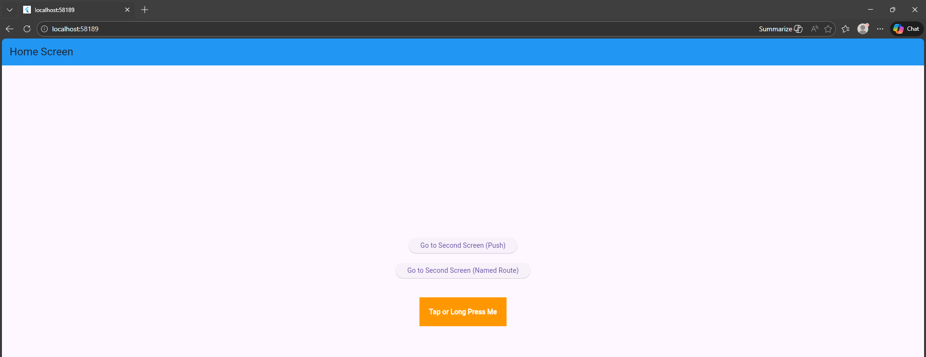
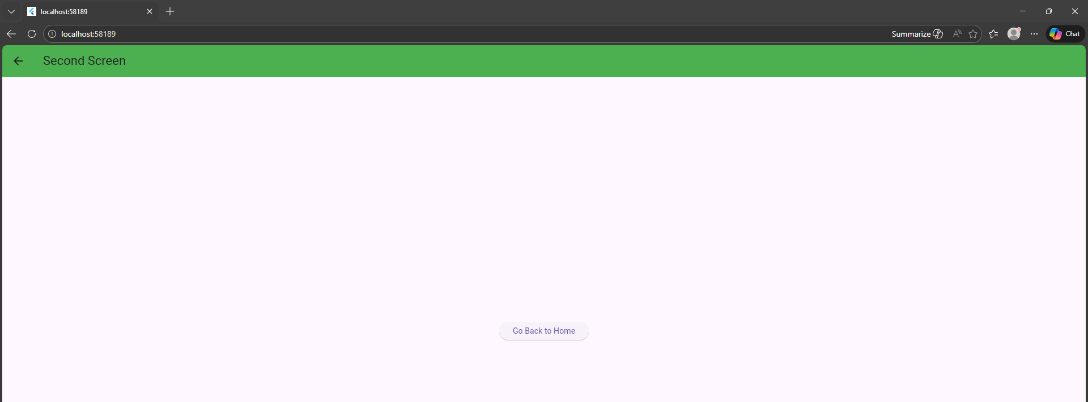
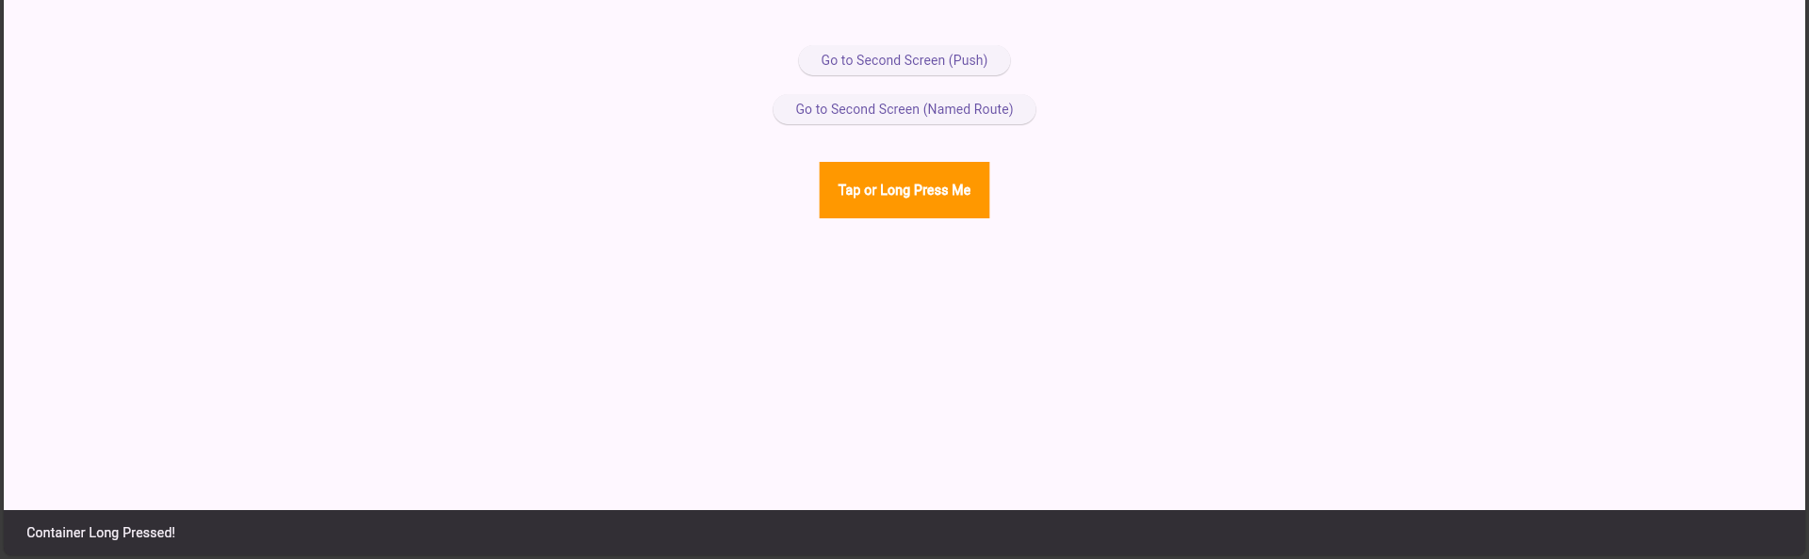

Conclusion
This experiment demonstrated navigation, named routing, and gesture handling in Flutter using Navigator methods and GestureDetector. It helped in understanding screen transitions and user interaction in a multi-screen application.

